Name: Kaustav Ghosh

Reg no: 180905188

Roll no: 29

Date:11/12/2020

Q1

#include <sys/types.h>

#include <sys/stat.h>

#include <unistd.h>

#include <stdio.h>

int main(int argc, char const *argv[])

{

struct stat sb;

int ret;

if (argc < 2)

{

fprintf(stderr, "usage: %s <file> \n", argv[0]);

return 1;

}

ret = stat(argv[1], &sb);

if (ret)

{

perror("stat");

return 1;

}

printf("File inode number is %d \n", argv[1], sb.st_ino);

return 0;

}

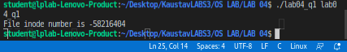

Q2

#include <sys/types.h>

#include <sys/stat.h>

#include <unistd.h>

#include <stdio.h>

int main(int argc, char const *argv[])

{

struct stat sb;

int ret;

if (argc < 2)

{

fprintf(stderr, "usage: %s <file> \n", argv[0]);

return 1;

}

ret = stat(argv[1], &sb);

if (ret)

{

perror("stat");

return 1;

}

printf(" ID of device containing file %d \n", sb.st_dev);

printf(" inode number %d \n", sb.st_ino);

printf(" permissions %d \n", sb.st_mode);

printf(" number of hard links %d \n", sb.st_nlink);

printf(" user ID of owner %d \n", sb.st_uid);

printf(" group ID of owner %d \n", sb.st_gid);

printf(" device ID (if special file) %d \n", sb.st_rdev);

printf(" total size in bytes %d \n", sb.st_size);

printf(" blocksize for filesystem I/O %d \n", sb.st_blksize);

printf(" number of blocks allocated %d \n", sb.st_blocks);

printf(" last access time %d \n", sb.st_atime);

printf(" last modification time %d \n", sb.st_mtime);

printf(" last status change time %d \n", sb.st_ctime);

return 0;

}

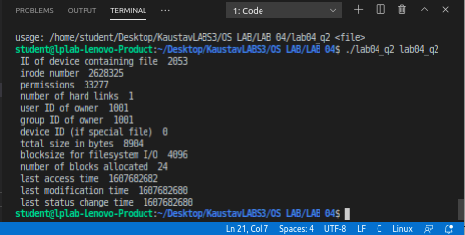

Q3

#define _POSIX_SOURCE

#include <fcntl.h>

#include <sys/types.h>

#include <sys/stat.h>

#include <unistd.h>

#include <stdio.h>

#include <stdlib.h>

int main(int argc, char const *argv[])

{

struct stat sb;

int ret;

if (argc < 2)

{

fprintf(stderr, "usage: %s <file> \n", argv[0]);

return 1;

}

char sln[] = "test.link";

puts("Before link()");

system("readlink -f test.*");

// Hard link

if (link(argv[1], sln) != 0)

{

perror("link error");

unlink(argv[1]);

}

else

{

puts("After link()");

system("readlink -f test.*");

unlink(argv[1]);

puts("after first unlink()");

system("readlink -f test.*");

unlink(sln);

}

return 0;

}

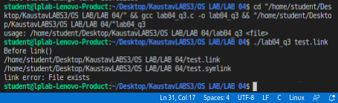

Q4

#define _POSIX_SOURCE

#include <fcntl.h>

#include <sys/types.h>

#include <sys/stat.h>

#include <unistd.h>

#include <stdio.h>

#include <stdlib.h>

int main(int argc, char const *argv[])

{

struct stat sb;

int ret;

if (argc < 2)

{

fprintf(stderr, "usage: %s <file> \n", argv[0]);

return 1;

}

char sln[] = "test.symlink";

puts("Before symlink()");

system("readlink -f test.*");

// Soft Link

if (symlink(argv[1], sln) != 0)

{

perror("symlink error");

unlink(argv[1]);

}

else

{

puts("After symlink()");

system("readlink -f test.*");

unlink(argv[1]);

puts("after first unlink()");

system("readlink -f test.*");

unlink(sln);

}

return 0;

